**Automated LAMP Setup Using Ansible**

**Introduction:**

**LAMP** stands for **Linux**, **Apache**, **MySQL** and **PHP**.This is a very popular stack of technologies that web developers use to build apps

* 1. Let us create an index.html file, by executing the below command.

# cd ansible

# cat > index.html << EOF

Welcome to Ansible Training!!

EOF

* 1. Let’s deploy a LAMP stack and publish your website using Ansible. Here we are going to write the complete Ansible Playbook to Install **Apache,** MYSQL database, **PHP** on **CentOs** machine and deploy your webpage.

Let us download the file from GitHub

# wget https://raw.githubusercontent.com/EyesOnCloud/LAMP-Setup-Using-Ansible/main/lamp.yaml

Output:

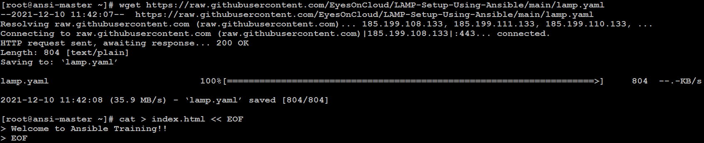

# cat -n lamp.yaml

Output:

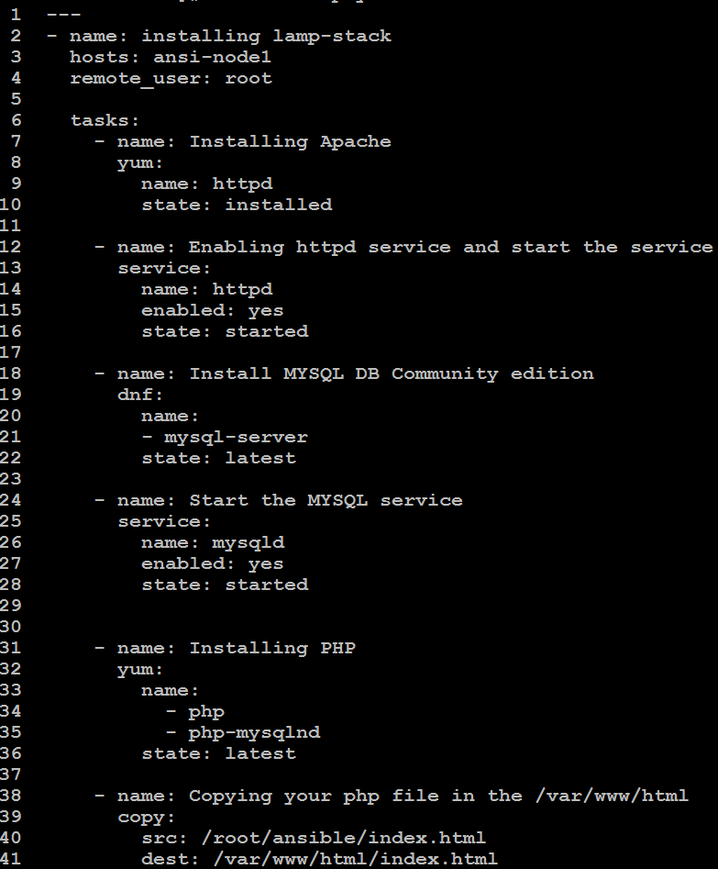

Let’s run the playbook

# ansible-playbook -vv lamp.yaml

Output:

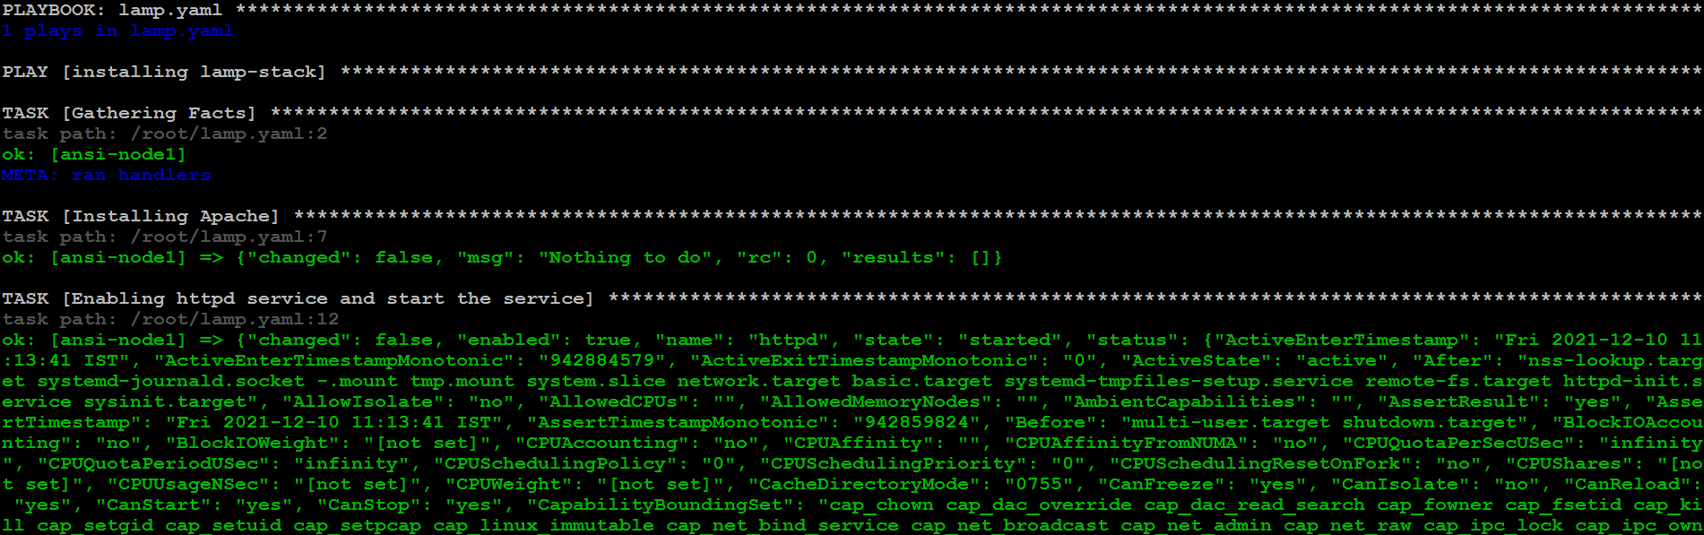

Lets verify jump to ansi-node1

# curl localhost

**Output**:

